CERN Courier
Jul 19, 2013

Faces & Places (page 2)

2013 Markov prize recognizes progress in neutrino oscillations
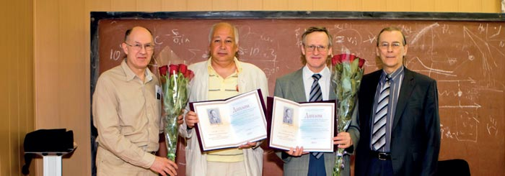
Contributions to the study of neutrino oscillations in experiments with accelerator and reactor neutrinos, and to the measurement of the mixing angle θ₁₃, link the winners of the 2013 Markov Prize. Yury Kudenko of the Institute for Nuclear Research (INR) of the Russian Academy of Sciences (RAS), Moscow, and Alexander Olshevsky, head of the Nuclear Problems Laboratory of JINR, Dubna, received the award at the 2013 Markov Readings held at the INR on 14 May.
Under Kudenko’s leadership, the Russian group working on the long-baseline experiment T2K in Japan developed a unique scintillation detector for the near detector. The group continues to participate in data taking and analysis. Olshevsky is a leader of the JINR teams working on the OPERA and the Daya Bay neutrino-oscillation experiments. He and his group made significant contributions to the precision measurement of θ₁₃ at Daya Bay.
The Markov Prize was established by INR-RAS in commemoration of Moisey Markov (1908–1994), one of the founders of the institute. The prize is awarded each year at the Markov Readings, an international seminar held to commemorate the Russian physicist, who made pioneering contributions to neutrino physics, as well as to quantum gravity and at the borderline between particle physics and cosmology.

